**Set up VirtualBox for CentOS7 on MacOS machine**

Download VirtualBox

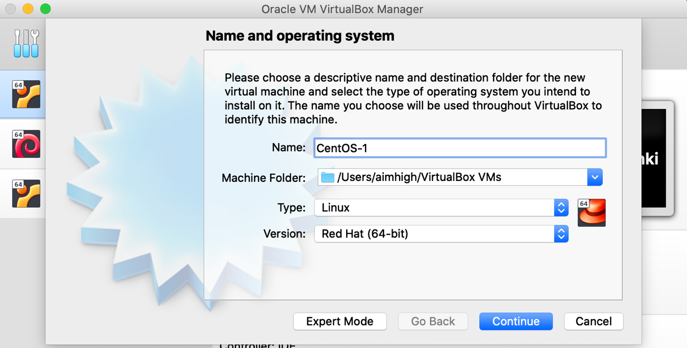

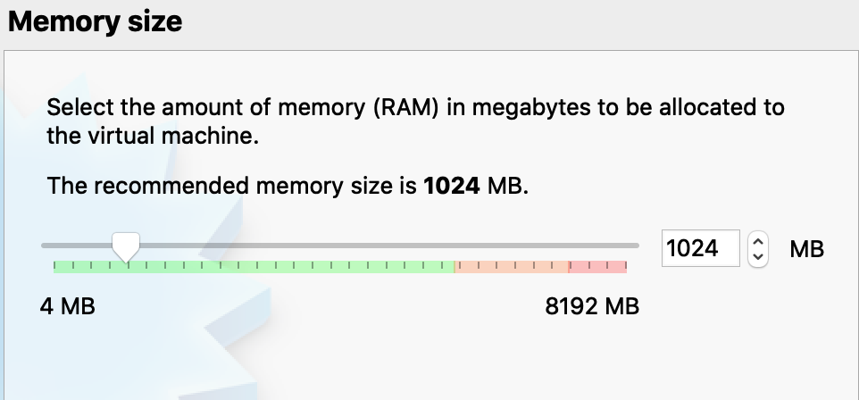

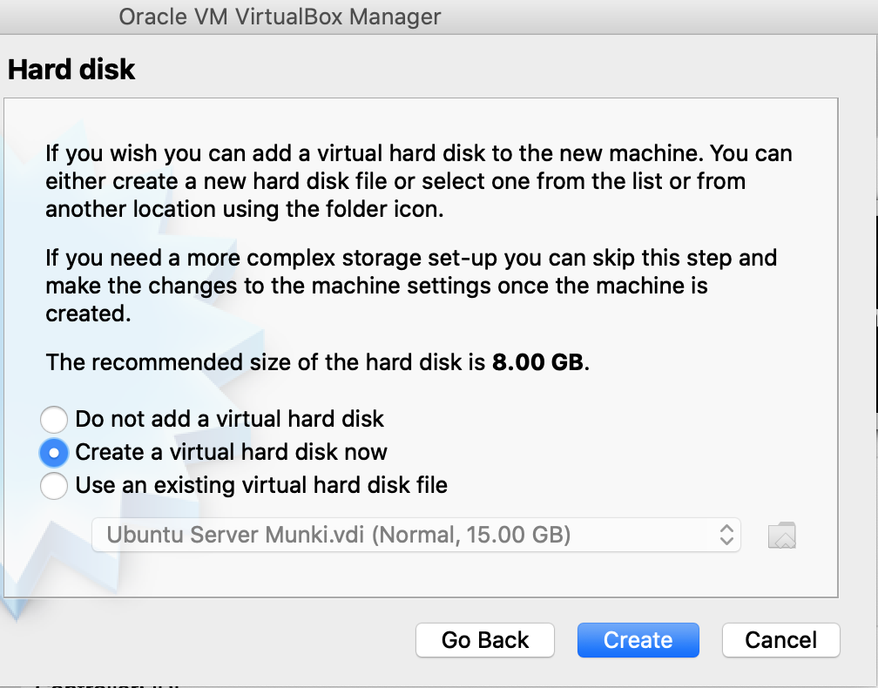

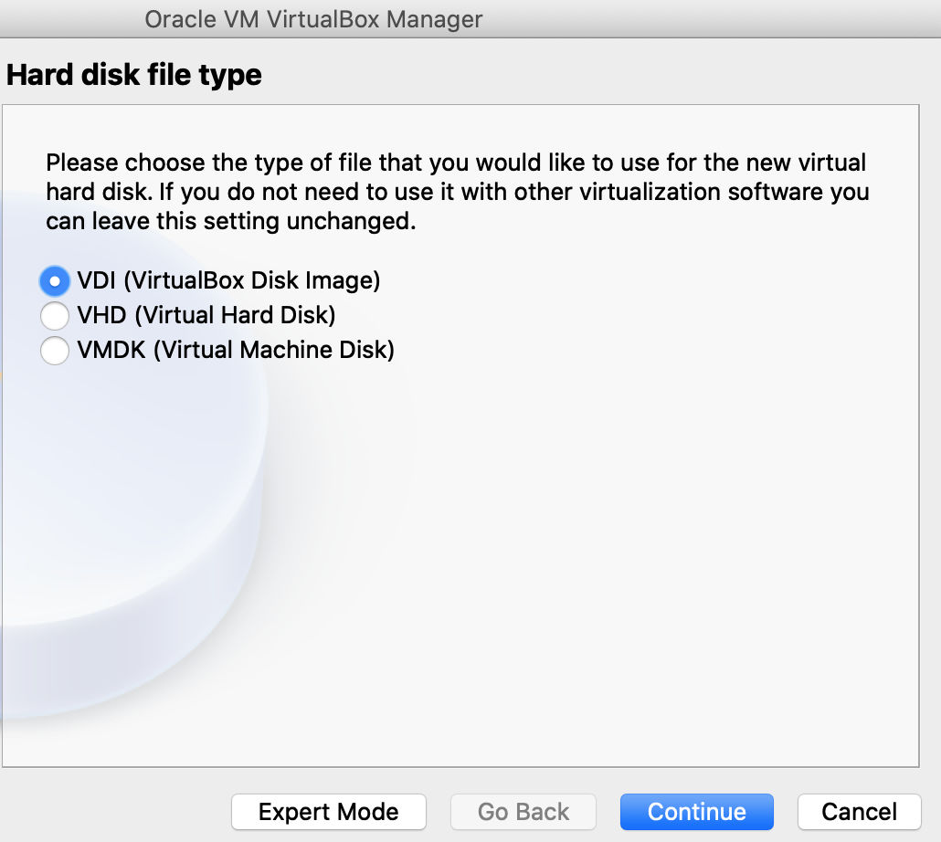

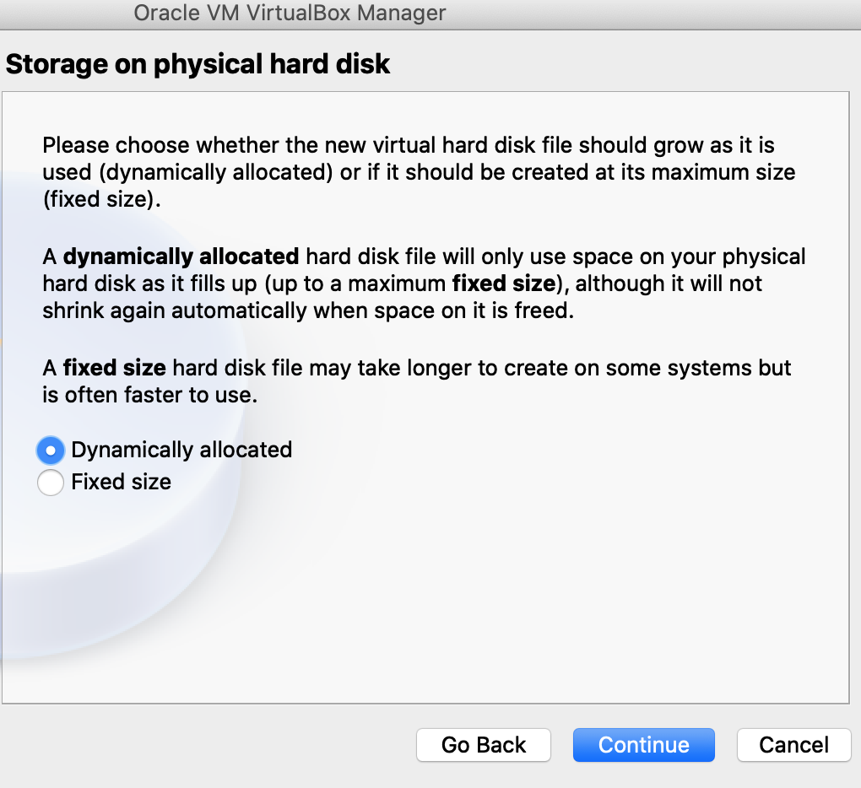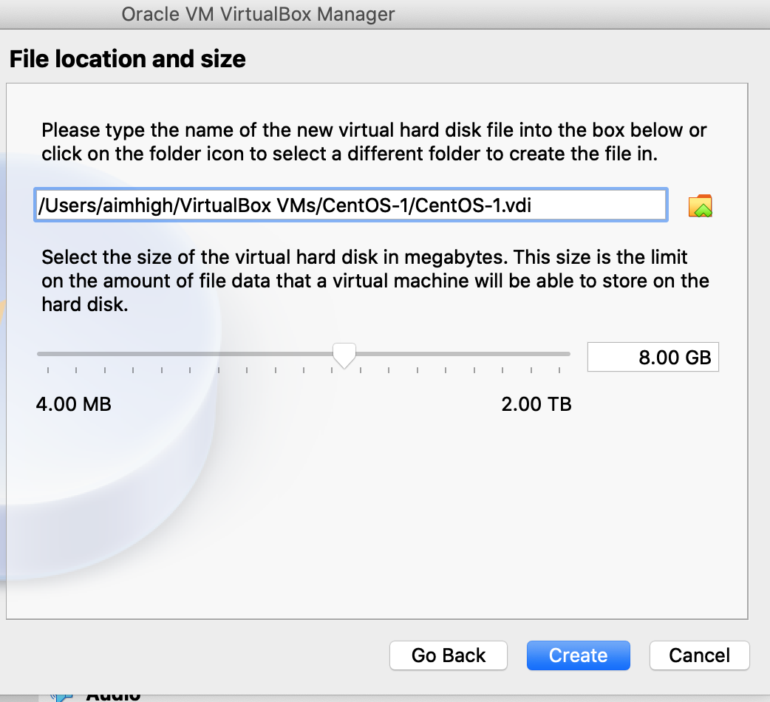

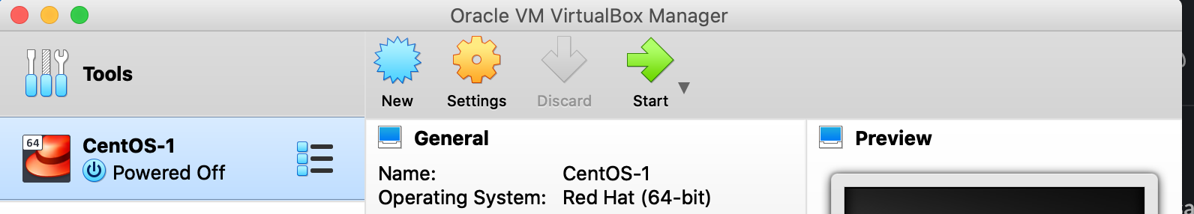

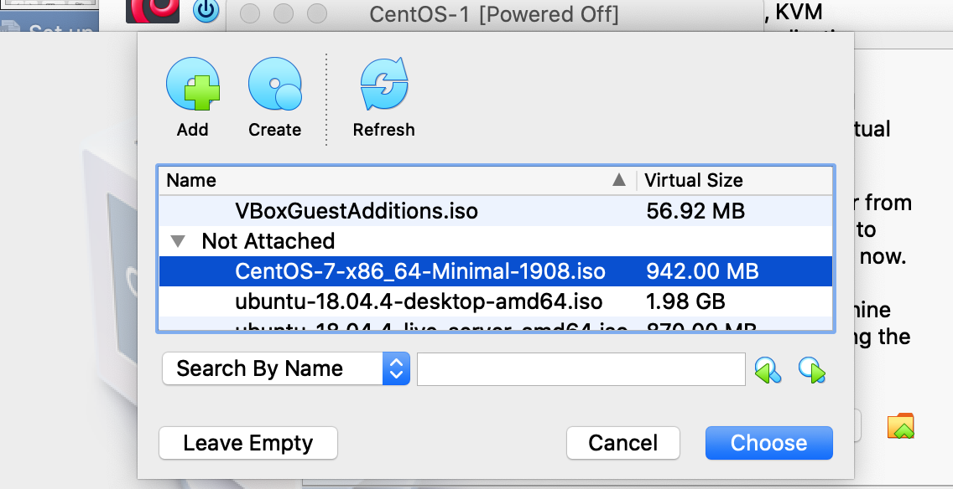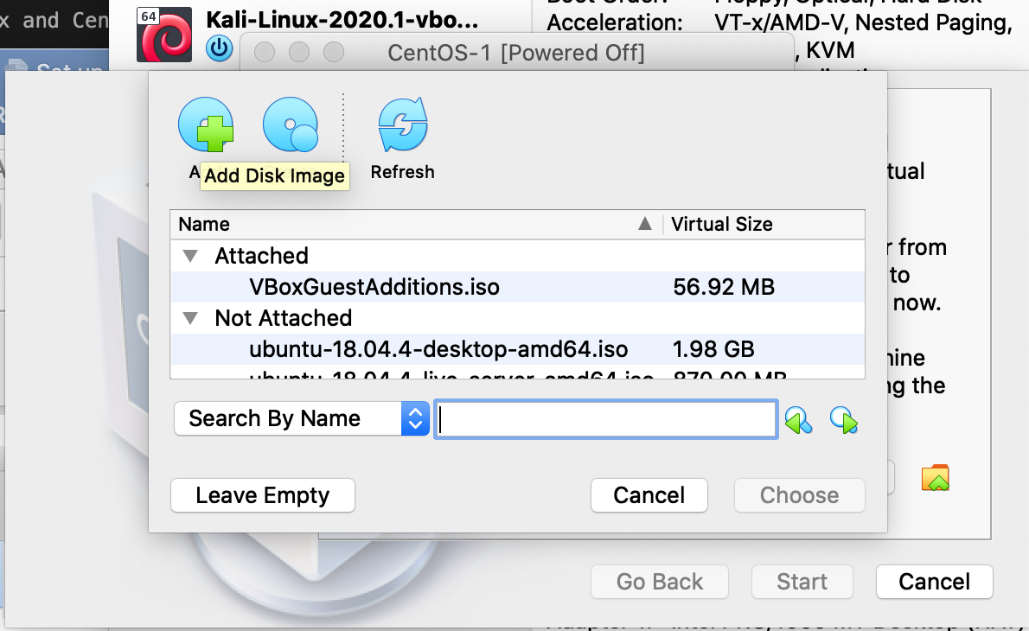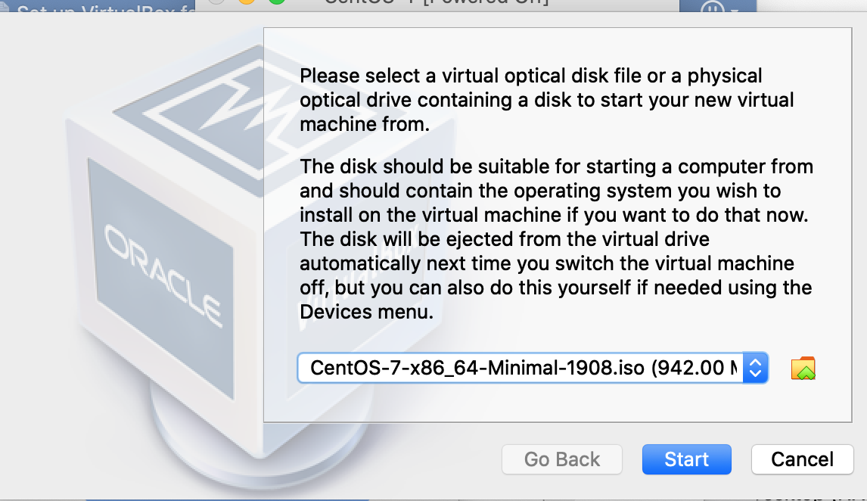

Start CentOS-1 VM

Hover over “Install CentOS 7 Media” option and press [ Enter ]

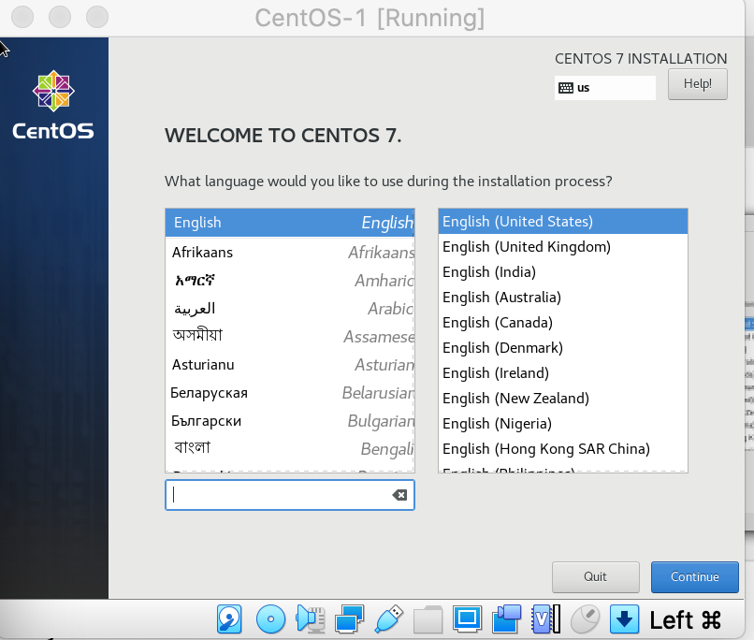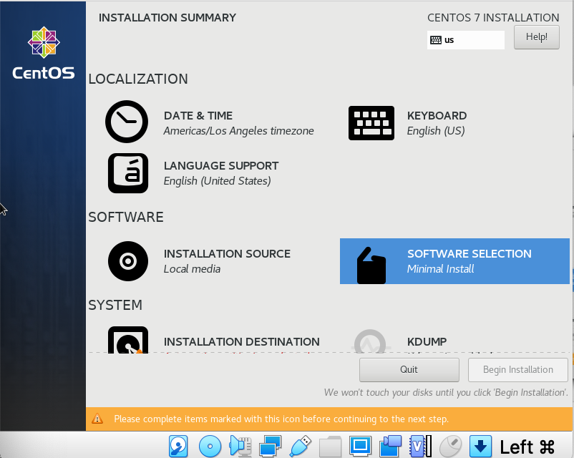

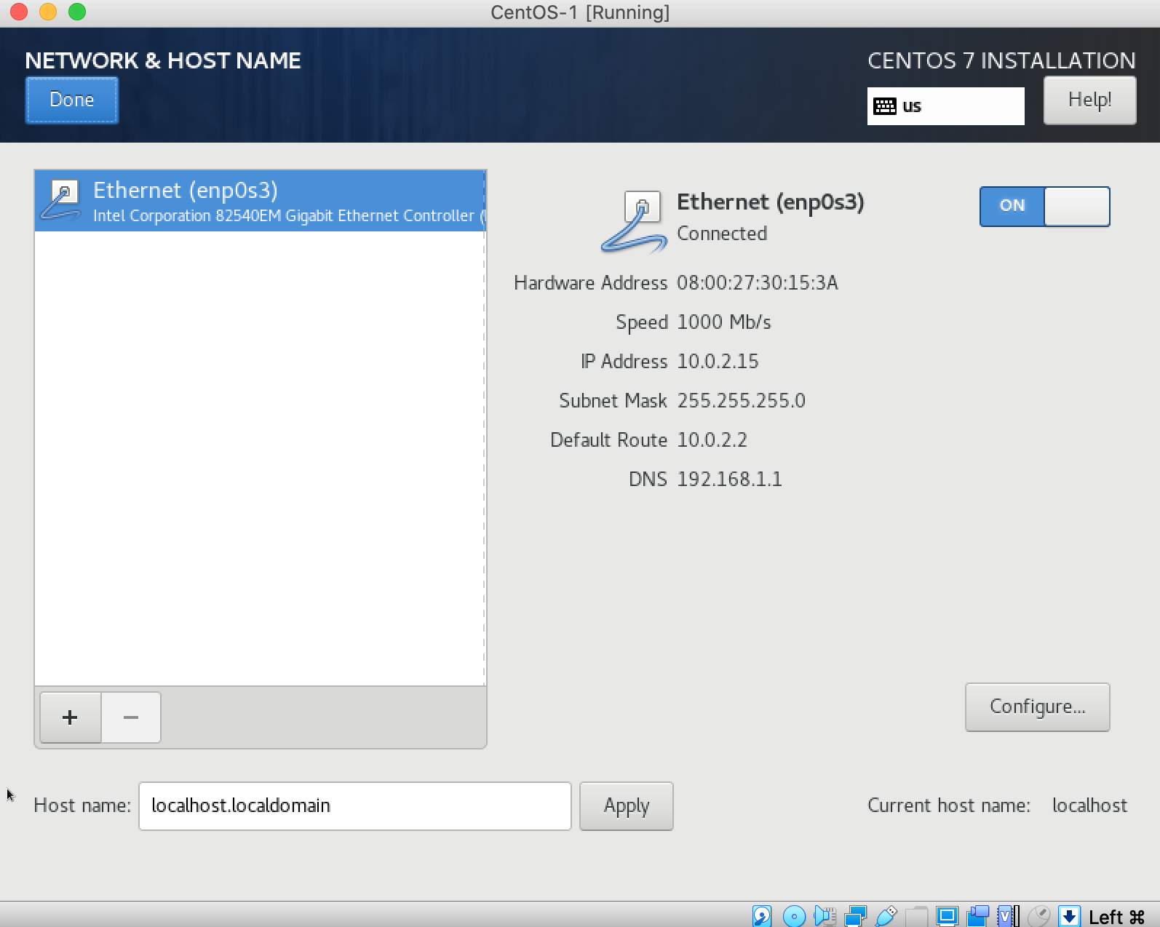

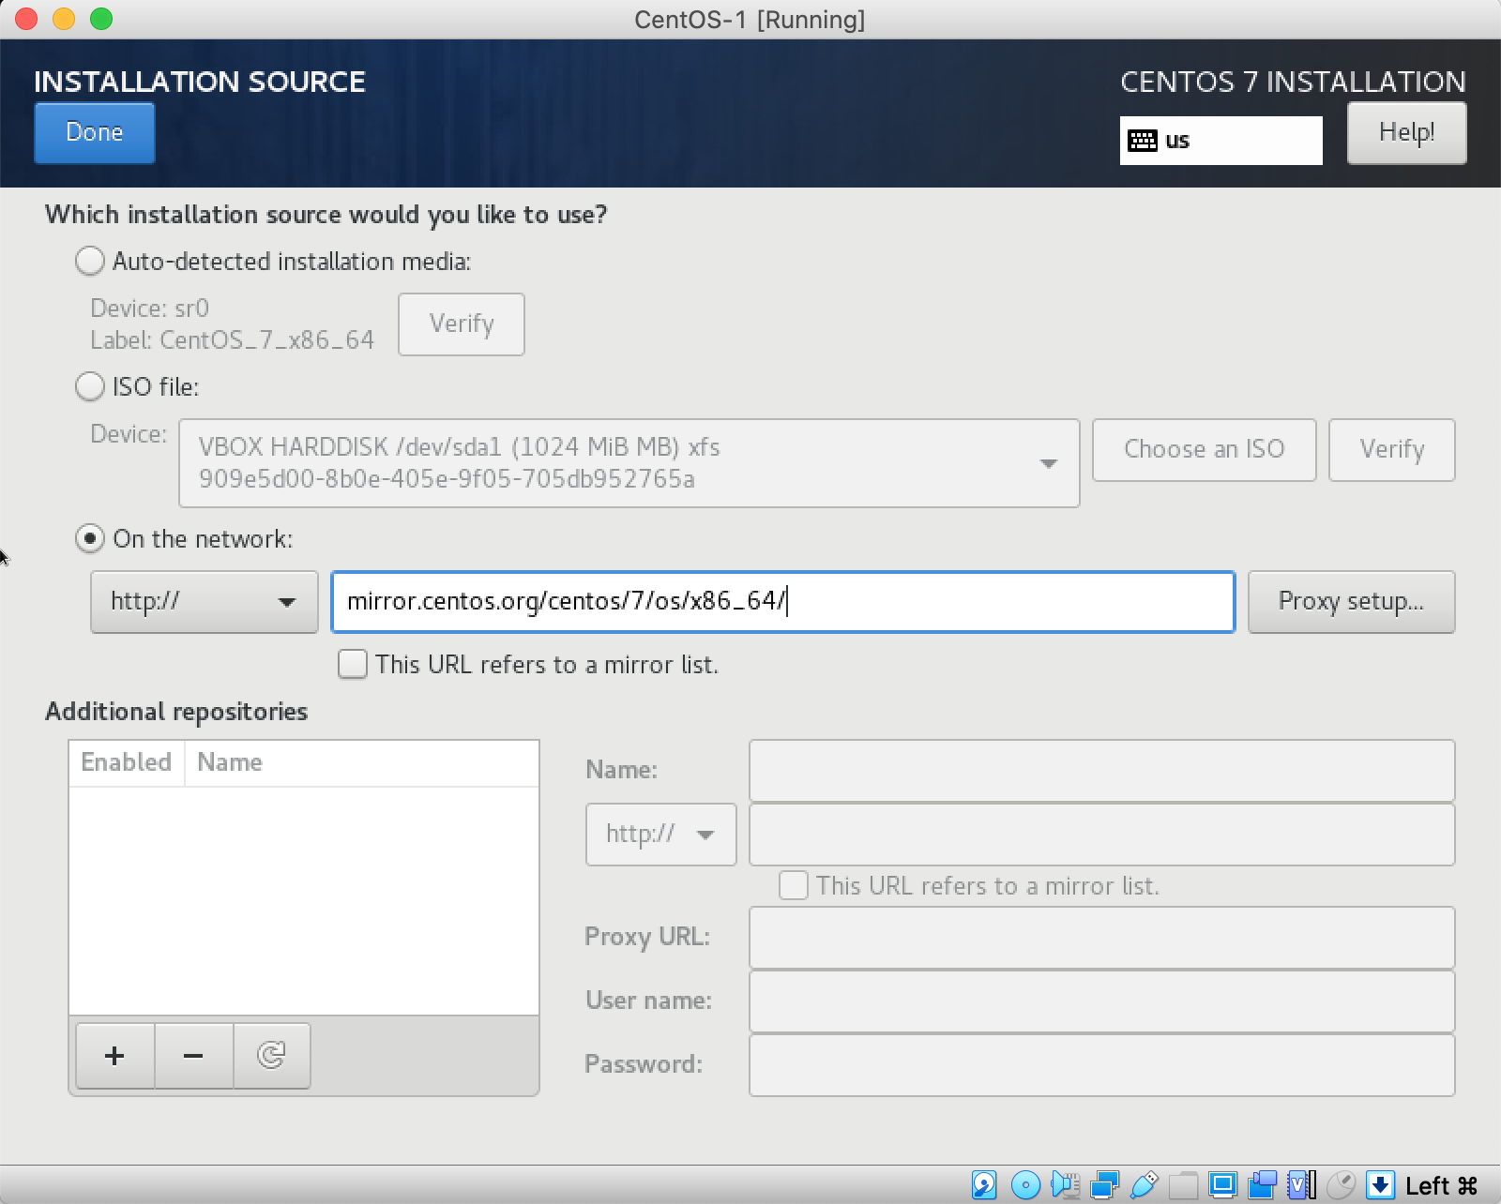

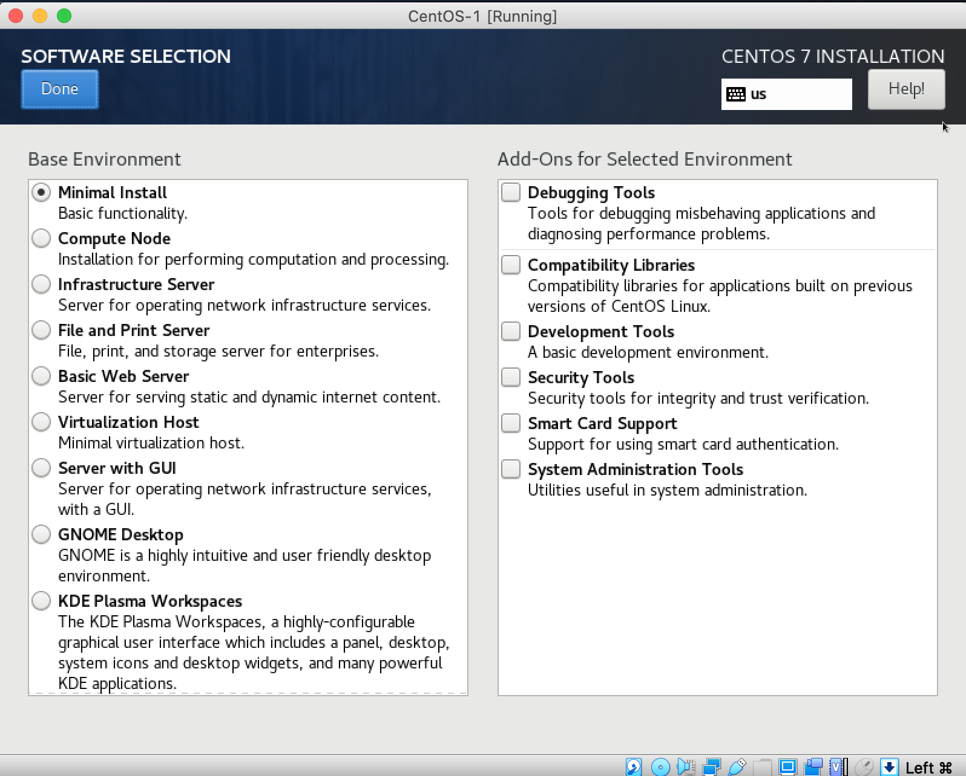

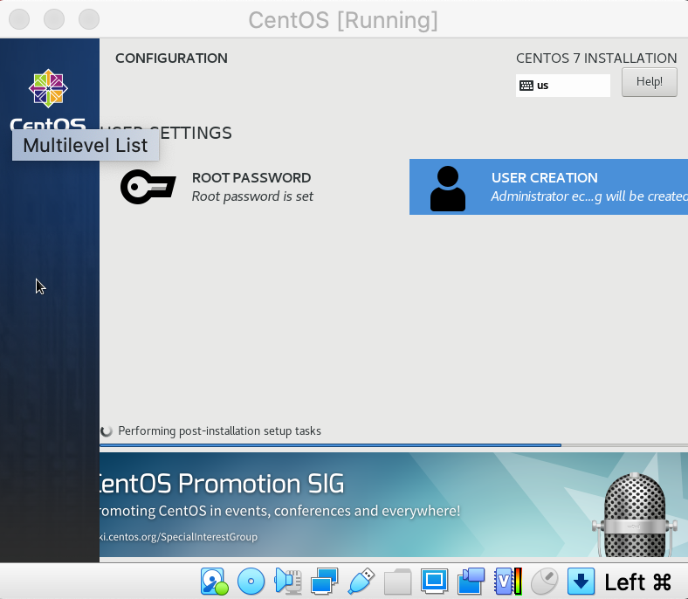

Log into VM from the host via SSH

On your VM (CentOS): Enable sshd service to start when server is booted and start it.

$ sudo systemctl enable sshd

$ sudo systemctl start sshd

$ sudo systemctl status sshd

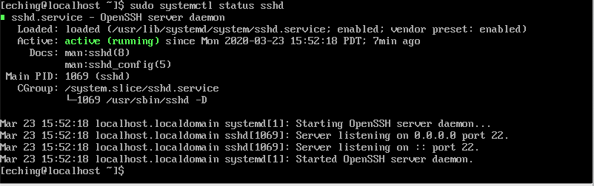

Set up port forwarding for the VirtualBox NAT network

On VirtualBox’s CentOS > Settings > Network > Advanced > Port Forwarding

Map localhost:2222 on host (MacOS) to 10.0.2.15:22 on guest (CentOS)

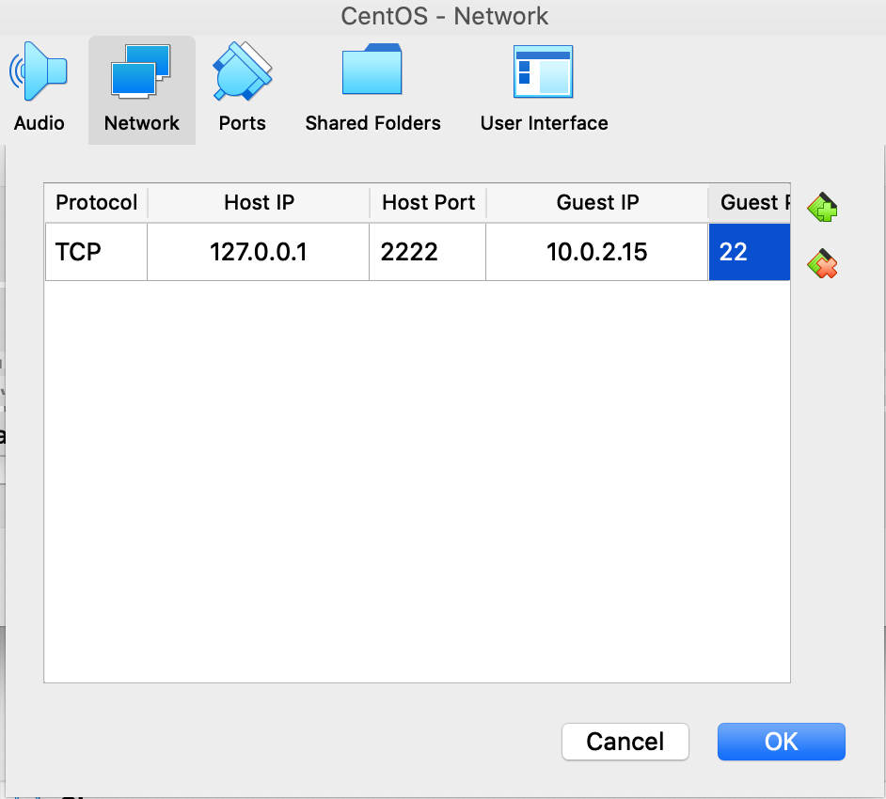

Now we can ssh into our CentOS VM:

$ ssh [eching@127.0.0.1](mailto:eching@127.0.0.1) -p 2222

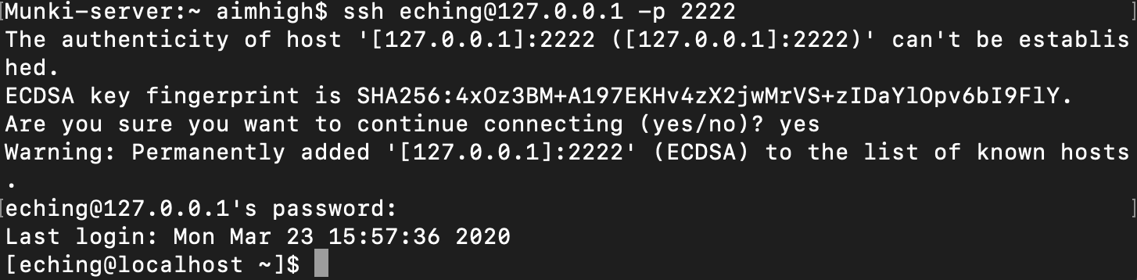

Update your VM

$ sudo yum update

If updating kernel or initialization system, do a reboot. Most likely will be the case when setting up new VM.

$ sudo systemctl reboot